Minoxsys - Snapshot

High Level Design Document

Author | Last Modified | Last Saved
Oana Axente | Lazăr Mihai | 4/23/2009 7:54 PM
Approval list

Table of Contents

I. Introduction 3
I.a. Purpose 3
I.b. Scope 3
I.c. Definitions, Acronyms and Abbreviations. 4
I.d. References 5
II. The Architectural Overview 6
II.a. Architectural goals and trade-offs 6
II.b. Technology selection 6
II.c. General system architecture 6
III. General system architecture 9
IV. Document Approvals 10

Introduction

This document offers a comprehensive architectural overview of the system. It captures the major architectural entities, decisions and trade-offs.

Purpose

The intended audience of this document is the development team and the technical representative of the customer. The purpose of the document is to present the overall system architecture, therefore guiding the development and deployment activities.

Scope

In this subsection:

- Identify all the major modules by name and provide the scope overview for them;
Module | Mnemonic
Outpost Management | OM | Manages outpost data and geographical (country, region and district) data so that the outposts can be logically grouped into a simple geographical hierarchy for future reporting purposes.
User Management | UM | Manage clients, users, roles
Product Management | PM | Manages product items and groups product items
Messages Management | MM | Manages the SMS Gateway in order to send/receive SMS Messages and process SMS Messages, and keeps track of email messages requested by the system.
Analysis Management | AM | Holds the business logic for retrieving reporting data
Campaign Management | CM | Allows the user to define Campaigns ( a filter for selecting geographical data ), Schedules ( time intervals at which the system needs to execute a task), Product level requests (sends requests to outposts using either email, or SMS)

- Identify all the use cases to be produced (even if only an overview);
UC1: User should be able to manage Location data
UC2: User should be able to manage Product data
UC3: User should be able to manage Client, User, Role data
UC4: User should be able to send and receive SMS messages
UC5: User should be able to view analysis reports based on what data enters/exists the application
UC6: User should be able to define campaigns, schedules and product level requests

- Identifies:
- The SMS Gateway that will be used;

This should be an executive-level summary that will be detailed later in the content of the current document.

Definitions, Acronyms and Abbreviations.

Iaas (Infrastructure as a Service) | IaaS provides abstract IT infrastructure resources such as CPU, storage and memory as services. A Cloud provider manages the physical infrastructure; provisions virtualized instances of operating systems to the cloud consumer. The consumer here is given complete ownership of the virtual image which he/she can choose to configure as they think appropriate.
Paas (Platform as a Service) | PaaS is the next higher level of abstraction in which not only do the technical infrastructure resources, as discussed above, but essential application infrastructure services such as computation, messaging, structured data persistence, connectivity, access control, etc, form a part of the service offering.
SaaS (Software as a Service) | A web-based software deployment model that makes the software available entirely through a web browser.
Windows Azure | Provides a Windows-based environment for running applications and storing data on servers in Microsoft data centers.
SQL Azure | Provides multiple storage services that are highly durable, scalable as well as constantly available. Azure storage provides users with capabilities to persist both structured as well as unstructured data.
Web Role | The Web role instance accepts incoming HTTP (or HTTPS) requests via Internet  Information Services (IIS) 7. A Web role can be implemented using ASP.NET, WCF, or another technology that works with IIS. Windows Azure provides built-in load balancing to spread requests across Web role instances that are part of the same application.
Worker Role | A Worker role instance cannot accept requests directly from the outside world, and IIS isn’t running in its VM. It typically gets its input via a queue in Windows Azure storage. The messages in this queue might come from a Web role instance, an on-premises application, or something else. A Worker role instance can send output to another queue or to the outside world. A Worker role instance is a batch job. Befitting this generality, a Worker role can be implemented using any Windows technology with a main() method.
Access Control  Service | Working with identity is a fundamental part of most distributed applications. Based on a user’s identity information, an application makes decisions about what that user is allowed to do. Applications can rely on tokens defined using the Security Assertion Markup Language (SAML). A SAML token contains claims, each of which carries some piece of information about a user. One claim might contain her name, another might indicate her role, such as manager, while a third contains her email address. Tokens are created by software known as a security token service (STS), which digitally signs each one to verify its source.
Bus Service | Provides secure messaging and connectivity capabilities that enable building distributed and loosely-coupled applications in the cloud, as well hybrid application across both on-premises and the cloud. It enables using various communication and messaging protocols and patterns, and saves the need for the developer to worry about delivery assurance, reliable messaging and scale.
Microsoft .NET Services | Offers distributed infrastructure services to cloud-based and local applications.
Microsoft SQL Services | Provides data services in the cloud based on SQL Server.
Live Services | Through the Live Framework, provides access to data from Microsoft’s Live applications and others, and allows synchronizing this data across desktops and devices, finding and downloading applications, and more.
ASP.MVC | Gives a powerful, patterns-based way to build dynamic websites that enables a clean separation of concerns and that gives you full control over markup for enjoyable, agile development. ASP.NET MVC includes many features that enable fast, TDD-friendly development for creating sophisticated applications that use the latest web standards.
IoC/DI | Inversion of control/Dependency Injection allows components to be developed in isolation and assembles them at a higher abstraction level.

References

In this subsection:
(1) Provide a complete list of all documents referenced elsewhere in the HLD
(2) Identify each document by title, report number (if applicable), date, and publishing organization
- Specify the sources from which the references can be obtained.

This information can be provided by reference to an appendix or to another document. If your application uses specific protocols or RFC’s, then reference them here so developers know where to find them.

The Architectural Overview
This is an architecture example of the Snapshot application.

Architectural goals and trade-offs

The architectural goals of using a Cloud platform are:
- Provide a SaaS solution to companies that want to track stock levels of specific products

Technology selection

The programming languages:
- C#
- HTML
- Javascript
- CSS

Frameworks:
- Sencha ExtJs on the UI, with jQuery and Underscore libraries
- ASP.NET MVC 3 on the back-end

Internet Browsers:
- Inernet Explorer 7+
- Mozilla FireFox 3+
- Safari 4+

Project tracking tool:
- JIRA

Distributed revision control system
- GIT

Continuous integration (CI) server
- Team City 6.5

Tools:
- Visual Studio 2010 for development
- Fluent NHibernate and NHibernate 3.1 for ORM configuration and mapping
- FluentMigrator for migrating the database
- Autofac as an IoC/DI tool
- Firebug and Chrome Developer tools for CSS&Javascript fixes
- NUnit for Unit and Integration testing
- Git for distributed version control
- SQL Server 2008 R2 Management Studio Express for database related tasks
- IIS 7.5 as the webserver

RDBMS

- SQL Server 2008 R2 as the database server.

AppHarbor as the cloud hosting provider

General system architecture

The general system architecture presents the general structure of the system as follows (repeat for each module):

Module (mnemonic)
OM | Description | Manage outpost data and geographical (country, region and district) data so that the outposts can be logically grouped into a simple geographical hierarchy for future reporting purposes.
OM | Layer | Presentation layer.
OM | Exported functionality | - User can create, edit, delete, and visualize a country  - User can create, edit, delete, and visualize a region  - User can create, edit, delete, and visualize a district  - User can create, edit, delete, and visualize an outpost  - When browsing country, region, districts user can see list of outposts when he has drilled to district level.
UM | Description | Manage clients, users, roles
UM | Layer | Service Layer
UM | Exported functionality | - Manage user data  - Manage role data  - Manage client data
PM | Description | Manage Products and Product groups
PM | Layer | Service Layer
PM | Exported functionality | - User can manage product groups  - User can manage products
AM | Description | Query live data and pull it into reports.  Allow defining the activities related to the business and the associated follow-up activities.
AM | Layer | Service Layer
AM | Exported functionality  - View reports in table and chart form showing core insights into stock level information for individual outposts, whole districts and entire regions  - See a list of outposts in distance order, who have excess levels of a stock item  - Check the stock level item  - Generates an alert when an outpost reports zero stock of a stock item  - View stock level current and historical information for a particular outpost
CM | Exported functionality | - Record all SMS gateway activity  - Record the history of activities for product level requests
CM | Description | Creates a "virtual object database" that can be used from within the programming language, no matter what RDBMS is used.
CM | Layer | Service Layer
ORM | Exported functionality | - translates the logical representation of the objects into an atomized form that is capable of being stored on the database, while somehow preserving the properties of the objects and their relationships so that they can be reloaded as an object when needed.
ORM | Description | Manages the SMS Gateway in order to send/receive a SMS Message and process a SMS Messages
ORM | Layer | Service Layer
MM | Exported functionality | - Send a request by SMS to all outposts to send in stock level information for a stock group  - Send a "message format error" SMS message to an outpost when stock level message format is not understood  - Send a "stock count reminder" message to an outpost if no stock information is received within an elapsed time  - Send a confirmation SMS message to an outpost when stock level data is successfully received  - Send a "message format error" SMS message to an outpost when stock level message format is not understood  - Send a confirmation SMS message to an outpost when stock level data is successfully received  - Process the SMS Message

General system architecture

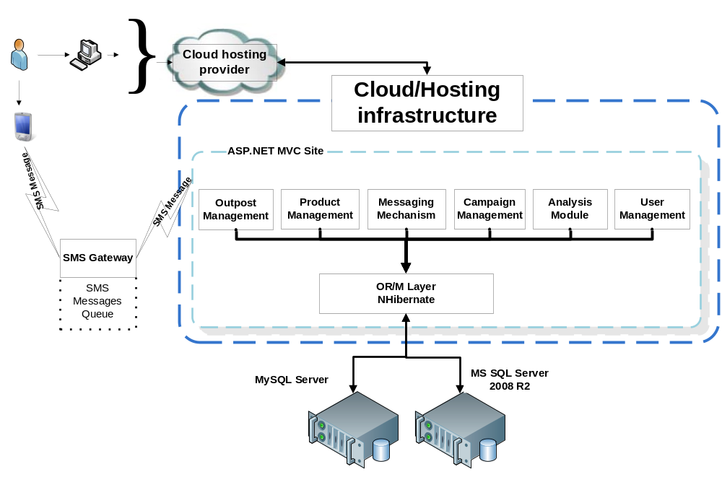

The application is developed on top of the ASP.NET MVC 3 framework. The user interface is written in JavaScript with Sencha ExtJs UI framework.
The hosting provider has to support ASP.NET MVC 3 and the .NET 4.0 Framework. Currently the application is running on a shared SQL Server R2 provided by AppHarbor.
Comunication with the database is handled by an ORM layer on the well established NHibernate library.

Document Approvals

Identify the approvers of the SRS document. Approver name, signature, and date should be used.

Version | Approver (name, signature, date)
Initial version
Change request 1(describe the sections affected and document version)
Change request 2 (describe the sections affected and document version)
Change request 3(re-evaluate the document based on the current state of the project)

